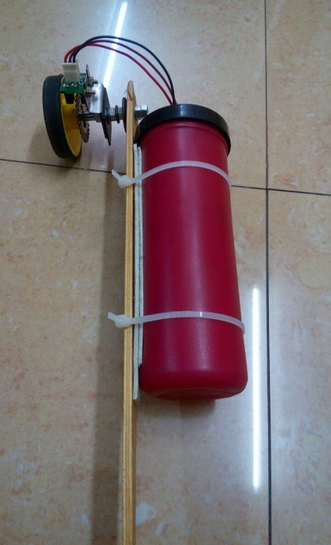DESIGNING THE BODY OF THE DIGIMETER

Having procured the wheel encoder, along with an Infra-Red sensor, the task was to build the body by mounting and aligning them in place, with a suitable container holding the circuitry.

For the alignment of the wheel and sensor, a metal bush was inserted and threaded in line with a shaft mounted with a plastic sleeve. Nuts and washers kept them in position ensuring the metal toothed disk was held intact between the transmitter and receiver of the IR sensor. The wheel was tested for smooth rotation in both directions while the shaft remained perpendicular and fixed. The container of suitable size was purchased to house Arduino, Bluetooth Module, Breadboard, Buzzer, and associated wiring. This system was attached to a flat wooden piece, long enough to maneuver the device.